**1.Modelo RF5_Indeg Apoio Reparacion Diques X All var**.

***Instrucciones modelo***: **test size = 0.21 ; rd_state = 41**

***Variables indep select to fit***:

variables = ['id', 'Indeg_RedeRisk_Cen', 'Indeg_RedeConfianc',

 'PC1_Distance_Pro', 'Degree_RedeTotFamil', '1_VarExp_Moranca', '9_VarExp_Atri_IndMelhorTecnDiqCint', '10_VarExp_Atri_MelhorTecnTubos', 'OutDeg_IntimAmigos_', 'OutDeg_RedeRisk_Cen',    'OutDeg_RedeConfianc' ]

***Model performance (scores):***

Mean Squared Error: 1.6071

R^2 Score: 0.5006 (In Excel: R2 = 0.5523 ; y = 0.36892 X + 1.1324)

**Model tot:**

Mean Squared Error (MSE): 0.6202

Root Mean Squared Error (RMSE): 0.7875

Mean Absolute Error (MAE): 0.4496

R^2 Score: 0.7737

Pearson Correlation: 0.8960

***Interactions***:

| **Interacción** | **Importancia** | **Dirección** |
| --- | --- | --- |
| 0 | (10_VarExp_Atri_MelhorTecnTubos, OutDeg_RedeCo... | 0.842044 | 0.032883 |
| 1 | (Indeg_RedeConfianc, OutDeg_RedeConfianc) | 0.809453 | 0.021444 |
| 2 | (OutDeg_RedeRisk_Cen, OutDeg_RedeConfianc) | 0.806219 | 0.020965 |
| 3 | (OutDeg_IntimAmigos_, OutDeg_RedeConfianc) | 0.745447 | 0.095972 |
| 4 | (9_VarExp_Atri_IndMelhorTecnDiqCint, OutDeg_Re... | 0.737744 | 0.008229 |
| 5 | (1_VarExp_Moranca, OutDeg_RedeConfianc) | 0.730773 | -0.021467 |
| 6 | (PC1_Distance_Pro, OutDeg_RedeConfianc) | 0.721134 | -0.002849 |
| 7 | (Degree_RedeTotFamil, OutDeg_RedeConfianc) | 0.698251 | 0.050093 |
| 8 | (Indeg_RedeRisk_Cen, OutDeg_RedeConfianc) | 0.684068 | 0.013091 |
| 9 | (OutDeg_IntimAmigos_, OutDeg_RedeRisk_Cen) | 0.572484 | 0.105852 |

***Key results****:*

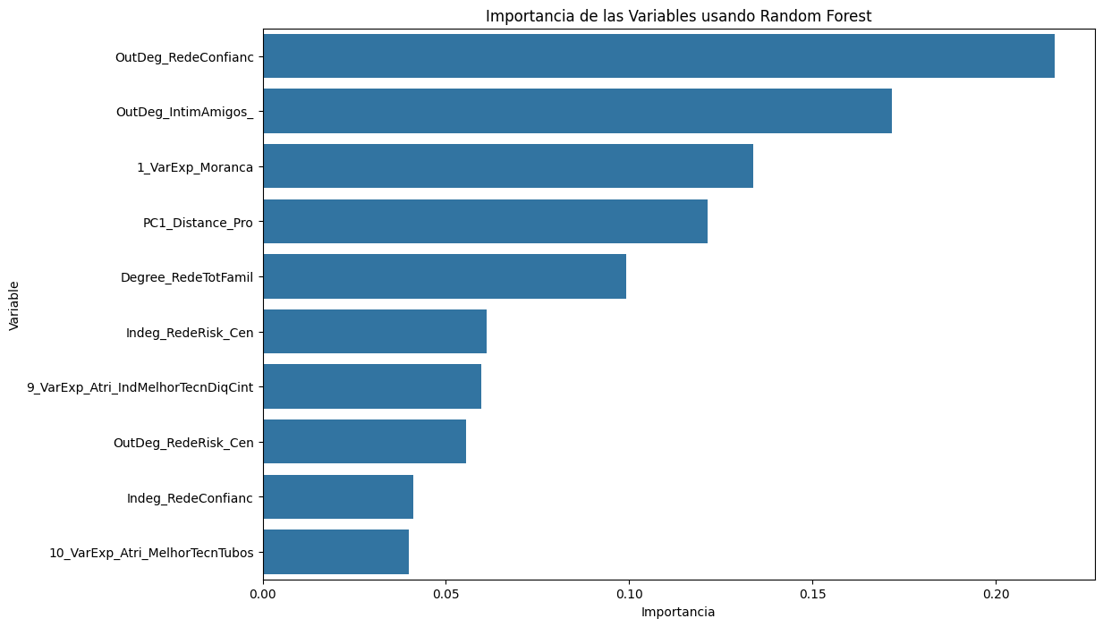

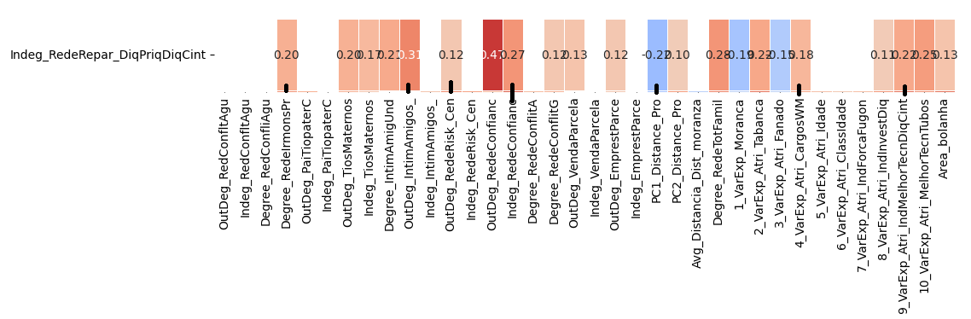

**[EN INTEGRANT Var Melhor tecnc tubos] 2.Modelo RF5_Outdeg Apoio Reparacion Diques X All var**.

***Instrucciones modelo***: **test size = 0.2 ; rd_state = 8**

***Variables indep select to fit***:

variables = [    'id',  'Indeg_IntimAmigos_', 'Indeg_RedeRisk_Cen',

,'Indeg_RedeConfianc', 'PC1_Distance_Pro', 'Degree_RedeTotFamil', '9_VarExp_Atri_IndMelhorTecnDiqCint', '8_VarExp_Atri_IndInvestDiq', '10_VarExp_Atri_MelhorTecnTubos', 'OutDeg_RedeRisk_Cen'  ]

***Model performance (scores):***

Mean Squared Error: 0.9231

R^2 Score: 0.8954 (In Excel: R2 = 0.9171 ; y = 0.8494 X + 0.1066 )

**Model tot:**

Mean Squared Error (MSE): 0.4496

Root Mean Squared Error (RMSE): 0.6705

Mean Absolute Error (MAE): 0.3101

R^2 Score: 0.9424

Pearson Correlation: 0.9737

***Interactions***:

| **Interacción** | **Importancia** | **Dirección** |
| --- | --- | --- |
| 0 | (Indeg_RedeConfianc, Degree_RedeTotFamil) | 2.906534 | 0.868603 |
| 1 | (Indeg_RedeRisk_Cen, Indeg_RedeConfianc) | 2.862202 | -0.031026 |
| 2 | (Indeg_RedeConfianc, Area_bolanha) | 2.842466 | 0.824496 |
| 3 | (Indeg_RedeConfianc, 8_VarExp_Atri_IndInvestDiq) | 2.841317 | 0.841762 |
| 4 | (Indeg_RedeConfianc, PC1_Distance_Pro) | 2.839120 | 0.851364 |
| 5 | (Indeg_RedeConfianc, OutDeg_RedeRisk_Cen) | 2.825571 | 0.840643 |
| 6 | (Indeg_IntimAmigos_, Indeg_RedeConfianc) | 2.820820 | 0.038098 |
| 7 | (Indeg_RedeConfianc, 10_VarExp_Atri_MelhorTecn... | 2.786963 | 0.812910 |
| 8 | (Indeg_RedeConfianc, 9_VarExp_Atri_IndMelhorTe... | 2.755088 | 0.819888 |
| 9 | (9_VarExp_Atri_IndMelhorTecnDiqCint, 10_VarExp... | 0.794884 | 0.071869 |

***Key results****:*

